**Evaluating Management Strategies for Atlantic Bluefin Tuna**

***Report 5: completion and release of the first comprehensive ABFT MSE package for use by stakeholders in MP testing.***

January 29th 2018

SHORT-TERM CONTRACT FOR MODELLING APPROACHES: SUPPORT TO BFT

ASSESSMENT (GBYP 06/2017) OF THE ATLANTIC-WIDE RESEARCH PROGRAMME ON

BLUEFIN TUNA (ICCAT-GBYP – Phase 7)

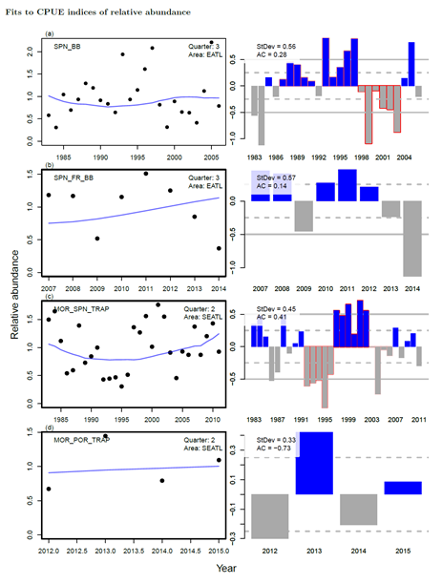

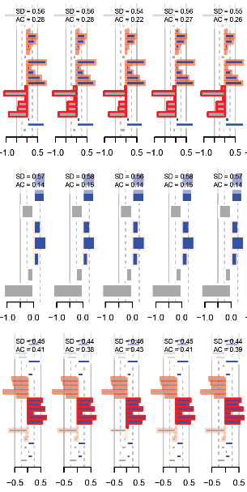

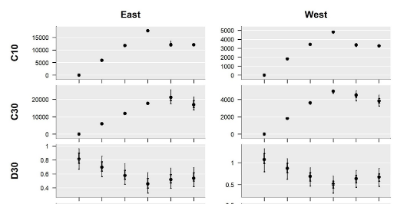

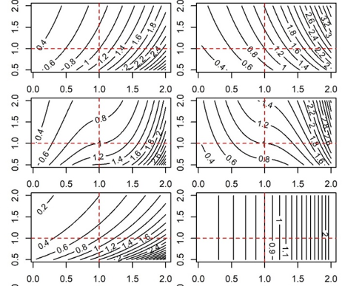

Tom Carruthers[1]

**Executive Summary**

The focus of this contract was the production of a fully documented working MSE framework including all finalized operating models (both reference and robustness) to allow stakeholders to develop and test their own Management Procedures. In this regard, a number of major milestones were achieved in this contract:

Operational modelling

- To accommodate the requirements of the reference and robustness operating models, the M3 model was updated from 1.3 through to 1.7.

- The [Trial Specifications](https://drive.google.com/open?id=14j33JBhoep0TtvRj4pBkA8cIwM7XhGz3) (Appendix 1) and the [meta-data base](https://drive.google.com/open?id=140HrddEWU_MFHhxizVtaO_uRs48tzPrEgbDMwudl_1M) (v2.0, Appendix 2) were been updated to include new OM definitions, performance metrics (Appendix 1) and data sources.

- All reference operating models were fitted to data and presented to the core modelling group including a summary SCRS paper ([Carruthers and Butterworth 2017a](https://drive.google.com/open?id=1uhkNrHlip7CTVn4CFMk4lJP22mi-y7RS), Appendix 3).

- The principal robustness operating models were fitted to data and are to be summarized in a 2018 SCRS paper.

- The 36 reference and 4 robustness operating models were included in the [ABT-MSE R package](https://drive.google.com/open?id=1eJQ_DcZcceYBBJAVNzqkLFxf4VProdZo) (v2.3.0) (Appendix 4) for use in MP testing.

- Functionality was added to specify the operating models of the R package using the MCMC posterior samples of the fitted M3 models (a better characterization of parameter uncertainty and cross-correlation).

MSE development

- Consistent with the performance metrics of the updated trial specifications document, the R package includes a performance table function getperf() and an MSE performance metrics plot PPlot() to standardize the outputs of user MSE runs (see Section 7.4.5 of the ABT-MSE R package user guide).

- Standardized operating model fitting reports ([an example](https://drive.google.com/open?id=1ppVm2mTsWjZsqtrl-RFQILsmO_OPNpJ0)) (Appendix 5) were updated following feedback from the Core Modelling Group including a new, additional OM comparison report ([see example for the reference operating models](https://drive.google.com/open?id=1HCzvlkzVStkHZL-As7AOQgYHuQl3-2-C)) (Appendix 5)

- All of the latest R code, data and objects were into the R package ([ABTMSE](https://drive.google.com/open?id=1eJQ_DcZcceYBBJAVNzqkLFxf4VProdZo) v2.3.0) with complete documentation for all functions, objects and data to be used in MSE analyses.

- The raw data, R scripts, Reports, help documentation and the R package were assembled in a single directory which can be downloaded from either the [ICCAT GitHub repository](https://github.com/ICCAT/abft-mse) or a [Google drive](https://drive.google.com/open?id=0B0TXcs-MLRl3c0w4VF9QbkJYOU0).

Documentation

* An SCRS paper was submitted to Redbooks demonstrating the design and implementation of new MPs in the R package: [Carruthers and Butterworth 2017b](https://drive.google.com/open?id=1gauaI74rowuzY3pAE-qFFlWQuY9wElPI) (Appendix 3)
* An SCRS paper was submitted to Redbooks introducing the ABT-MSE R package and its capabilities [Carruthers and Butterworth 2017c](https://drive.google.com/open?id=1IBcZhxNJXwSKkmEoAFoGrj7BhzilNt81) (Appendix 3)
* A draft peer-review paper has been produced describing and testing a multi-stock, multi-index management procedure designed specifically for Atlantic bluefin tuna ([Carruthers et al. 2018](https://drive.google.com/open?id=1gTsFebF_6jOSfQpsQSvWViVPy0tptHsc)) (Appendix 6)
* The user guides for [M3 (v1.7)](https://drive.google.com/open?id=1GwBgtHzPsk4uZVO5wPri8jiPVc-YgPlF) and [ABT-MSE R package (v2.3)](https://drive.google.com/open?id=1tlNj3NZ1VXNwWq46dVKbqUTQgUI8Fp70) have been updated with new tutorials and examples of MP development. The user guide was developed in R markdown that describes the file structure, the project and guides users through the various functions of the R package including worked examples of the 7 steps of MSE development (of Punt and Donovan, 2007)(Appendix 7).

- [Software design documentation](https://drive.google.com/open?id=1OcadeChBHx3SFouqayIBg6NuzgMSkwSR) was updated for the latest version of the ABT-MSE R package(v2.3.0) (Appendix 8).

Contents

1 Review of contract activities 2017 - 2018 4

1.1 Data preparatory meeting (March 6th – 11th) 4

1.2 Stock Assessment meeting (July 20th-28th) 4

1.3 Species group meetings (September 27th – 29th) 5

1.4 Developments since September 2017 5

2 Progress with respect to deliverables 6

3 Priorities for the MSE process 8

3.1 Software usability, support and debugging 8

3.2 Publish papers on MP development and testing 8

4 MSE development priorities 8

4.1 Vizualization tools 8

4.2 Data-rich MPs (major) 9

4.3 New observation error models for tagging data 9

5 References 9

6 Appendices 10

6.1 Appendix 1: Trial Specifications 10

6.2 Appendix 2: Meta Database 10

6.3 Appendix 3. SCRS papers. 10

6.4 Appendix 4: Complete R package for MP testing 11

11

6.5 Appendix 5: Standardized operating model reporting 11

6.6 Appendix 6: Draft peer-review paper on a Multi-stock, Multi-fleet, Multi-area MP 12

6.7 Appendix 7: Updated M3 user guide 12

6.8 Appendix 8: R package user guide 12

6.9 Appendix 9: Software design documents 13

# Review of contract activities 2017 - 2018

## Data preparatory meeting (March 6th – 11th)

The principal goal of the data preparatory meeting was to finalize data inputs and the priors for model parameters to reflect the 2017 stock assessments (VPA and SS assessments for Eastern and Western stocks).

In light of discussions at this meeting the MSE framework was updated to include new parameters for natural mortality rate, growth and maturity. Also finalized were the CPUE and survey indices that would be used to condition the operating model. These data were processed at the meeting and incorporated into the operating model fitting. The Trial Specifications document and Meta Database were updated to reflect these changes.

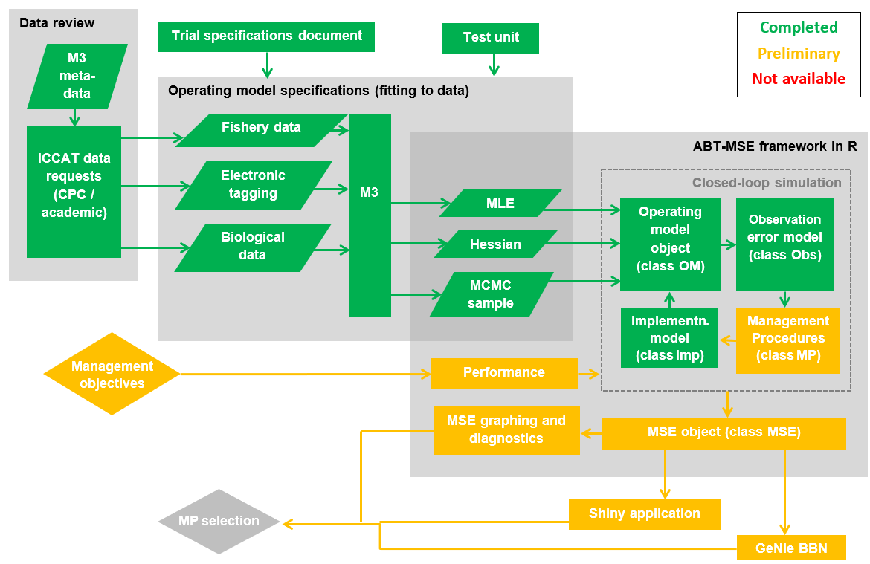

Figure 1. Current status of the components of the ABT MSE framework.

## Stock Assessment meeting (July 20th-28th)

Prior to the 2017 bluefin stock assessment meeting, the 8 reference operating models of the Trial Specifications (of that time) were fitted and a report produced for each. The assessment meeting provided the first opportunity to compare these operating model estimates to those of 4 individual assessments (Stock Synthesis / VPA for East / West).

Following the presentation of the assessment results and the fits of the reference operating models, the Core Modelling Group concluded that the range of operating models should encompass the range of historical stock trends and relative stock magnitudes predicted by the stock assessments. The Trial Specifications document was updated to include 18 new operating models in addition to revised maturity and mortality schedules that were proposed during the assessment process. The Core Modelling Group also suggested changes to the prior for recruitment to prevent unrealistically numerous recruitment predictions from the M3 model.

Feedback from the Core Modelling Group led to a revised operating model fitting report ([e.g. for reference operating model 1](https://drive.google.com/open?id=1ppVm2mTsWjZsqtrl-RFQILsmO_OPNpJ0)) and a new [summary report](https://drive.google.com/open?id=1HCzvlkzVStkHZL-As7AOQgYHuQl3-2-C) for comparing the most important aspects and fits of multiple operating models.

## Species group meetings (September 27th – 29th)

Three papers were presented on the fitting of operating models ([SCRS/2017/223](https://drive.google.com/open?id=1oJmXDD6tRKbEI4DwZnsLbFIAcq1EfiPt)), an example MP application ([SCRS/2017/224](https://drive.google.com/open?id=1gauaI74rowuzY3pAE-qFFlWQuY9wElPI)) and an introduction to the R Package ([SCRS/2017/225](https://drive.google.com/open?id=1IBcZhxNJXwSKkmEoAFoGrj7BhzilNt81)).

In the month following the assessment meeting, all OMs were refitted given the new Trial Specifications, data and recruitment priors. Prior to Redbooks submission, the first paper on operating models ([SCRS/2017/223](https://drive.google.com/open?id=1oJmXDD6tRKbEI4DwZnsLbFIAcq1EfiPt)) was revised to reflect these changes. Also revised were the OM reports and the summary report for all reference OMs.

The species group meetings provided a venue for discussing robustness operating models. The most important of these were prioritized and considered alternative scenarios for

1) Future catches in both the West and the East + Med are each year 20% bigger than the TAC as a result of IUU fishing (of which the MP is not aware)

2) An undetected increase in catchability for CPUE-based abundance indices of 1% per annum

3) Non-linear index-abundance relationships

4) Alternative mixing

## Developments since September 2017

The M3 operating model was revised (now v1.17) to allow for the scenarios of the new robustness operating models.

The default approach to specifying parameter uncertainty in operating models was to sample from the parameter variance-covariance matrix produced from the maximum likelihood estimates of the ADMB M3 model. Unfortunately this proved to be a poor approximation to the often complex, non-linear and ridged posterior space of the various movement, catchability and selectivity parameters. Instead, the M3 model was extended to allow for the production of Bayesian posterior estimates of parameters via the MCMC capabilities of ADMB.

A simple management procedure was included in the ABT-MSE R Framework User Guide ([Section 7.4.5](https://drive.google.com/open?id=1tlNj3NZ1VXNwWq46dVKbqUTQgUI8Fp70)) to provide a functioning workable example for users to follow. Additionally a [draft manuscript on a multi-stock MP](https://drive.google.com/open?id=1gTsFebF_6jOSfQpsQSvWViVPy0tptHsc) was produced and is currently being integrated into the ABT-MSE R Framework and tested prior to peer review.

To reflect the changes in both the M3 operating model and R framework, all help documentation ([M3 User Guide](https://drive.google.com/open?id=1GwBgtHzPsk4uZVO5wPri8jiPVc-YgPlF), [R Package User Guide](https://drive.google.com/open?id=1tlNj3NZ1VXNwWq46dVKbqUTQgUI8Fp70) and [Software Design Specification](https://drive.google.com/open?id=1OcadeChBHx3SFouqayIBg6NuzgMSkwSR) documents were updated.

Finally the [Meta Database](https://drive.google.com/open?id=13pFaM3BTnzQ1BNQGoYn4O2n1IeD18V3VTbN9Hv7139U) has been revised to reflect the latest data availability and highlight those that are currently used in the conditioning of operating models.

# Progress with respect to deliverables

|  |  |  |
| --- | --- | --- |
| **Deliverable 1 July 20, 2017 (100%)** | | |
|  | i | Workplan outlining the actions required to complete the final deliverables |
|  | ii | Presentation and short report summarizing current status of deliverables and actions required to achieve them |
|  |  |  |

1. The workplan was presented in [Progress Report 6](https://drive.google.com/open?id=1qTqupUrkDu0gHEmiUZMF8KnqQyDCYKKi)
2. This deliverable was addressed in [Progress Report 6](https://drive.google.com/open?id=1qTqupUrkDu0gHEmiUZMF8KnqQyDCYKKi) and accompanying presentations.

|  |  |  |
| --- | --- | --- |
| **Deliverable 2 September 23, 2017 (100%)** | | |
|  | i | Updated presentations and short report summarizing current status of deliverables and actions required to achieve them |
|  | ii | Examples based on agreed trials, to include output statistics and fully OM conditioning diagnostics |
|  | iii | Draft papers on application of MSE |
|  |  |  |

1. This was presented in [Progress Report 7](https://drive.google.com/open?id=1jGkMZUvG0SI_Z-BZ9iaZW9HM65bxE-5x).
2. Following feedback from Core Modelling Group at the Stock Assessment meeting, the [OM fitting reports](https://drive.google.com/open?id=1ppVm2mTsWjZsqtrl-RFQILsmO_OPNpJ0) were finalized in addition to a [new OM summary report](https://drive.google.com/open?id=1HCzvlkzVStkHZL-As7AOQgYHuQl3-2-C). The fits of the OM models were described in an SCRS paper ([2017/223](https://drive.google.com/open?id=1oJmXDD6tRKbEI4DwZnsLbFIAcq1EfiPt))
3. An SCRS paper ([2017/224](https://drive.google.com/open?id=1gauaI74rowuzY3pAE-qFFlWQuY9wElPI)) was produced documenting the MSE R framework being applied to a series of new management procedures

|  |  |  |  |
| --- | --- | --- | --- |
| **Deliverable 3 November 3, 2017 (100%)** | | | |
|  | i | Updated presentations and short report summarizing current status of deliverables and actions required to achieve them |
|  |  |  |

1. This was presented in [Progress Report 8](https://drive.google.com/open?id=1BeunZByTBxSCIgzIQsuO10MA4zMjjvVQ).

|  |  |  |
| --- | --- | --- |
| **Deliverable 4 February 21, 2018 (90%)** | | |
|  | i | Updated **Repository** with full tracking including version control for software development  <https://github.com/ICCAT/abft-mse> containing the OM |
|  | ii | Update of **SDP** (Software Development Plan) that will be reviewed by external experts, as agreed at Monterey meeting |
|  | iii | **Test Unit** so that code can be validated |
|  | iv | **Meta Database** summarizing all parameters and assumptions used  https://github.com/ICCAT/GBYP-MetaDB |
|  | v | Evaluation of **Management Procedures** implementation by 3rd parties.  Written up as SCRS papers and code available in repository |
|  |  |  |

1. The Repository was updated will the latest file structure that is also available from a Google Drive [here](https://drive.google.com/open?id=0B0TXcs-MLRl3c0w4VF9QbkJYOU0).
2. The Software Development Plan was revised to reflect the new phase of the MSE research in which collaborators will design and test their own MPs.
3. The test unit has been updated and rolled into the R package. It is described in [Section 9](https://drive.google.com/open?id=1tlNj3NZ1VXNwWq46dVKbqUTQgUI8Fp70) of the R Package User Guide.
4. The Meta Database has been updated and is available from a Google Drive [here](https://drive.google.com/open?id=140HrddEWU_MFHhxizVtaO_uRs48tzPrEgbDMwudl_1M). I do not have permission to upload this to the private ICCAT GitHub site at https://github.com/ICCAT/GBYP-MetaDB

**Current status of objectives**

|  |  |  |  |  |  |
| --- | --- | --- | --- | --- | --- |
| **Objective** | | | **Tasks (bold are completed)** | | |
|  | **i**  100% | Ensure the Operational Model (OM) implements the trials as specified by the 2016 CMG report. | | **Added (M3 v1.7):**  **age-based movement, plus group, model initialization at equilibrium estimated F, recruitment predicted from SSB in previous year, a prior for depletion to allow the model to fit specified depletion.** |
|  | **ii**  100% | Us the test unit to validate the age-based movement model | | **Now included in the R package for all users** |
|  | **iii**  50% | Work with third parties to add MPs to the MSE framework including empirical control rules and simple stock assessment methods | | In coordination with Doug Butterworth (CMG) and Paul de Bruyn (ICCAT) the R package and documentation (including a [covernote](https://drive.google.com/open?id=1eOq2vWoC-XjQf-884CYekrMU4SafVT7u)) has been circulated to prospective MP developers in Canada, USA, France, Morocco and Japan. |
|  | **iv**  50% | Run the MSE in collaboration with BFT Species group | | A demonstration MSE has been run and an SCRS paper describing preliminary results. However the intention of this Objective is presumably to summarize the results of MPs developed by stakeholders and as yet, none have been developed. |
|  | **v**  50% | Collaborate with the SCRS and others (e.g. rRFMOs) to develop interactive web based graphics to communicate MSE results to decision makers and stakeholders. | | The current [Shiny App](https://drive.google.com/open?id=1-xHUI02dwwv1g90c7c5dgAPbYOoMVh2d) (open server.R in RStudio and press ‘Run App’) serves as a demonstration of the type of online application that can be developed to explore and evaluate MPs. However since no MPs have been developed by stakeholders this App cannot yet be updated to reflect the latest MSE results. |
|  | **vi**  100% | Work with other to update and maintain the meta database of the available bluefin data and knowledge | | **The latest** [**meta database**](https://drive.google.com/open?id=140HrddEWU_MFHhxizVtaO_uRs48tzPrEgbDMwudl_1M) **(v2.0) has been made publically available and editable** |
|  |  |  | |  |

The objectives of this contract were compromised by delays in the finalization of the reference and robustness operating models. Once the Core Modelling Group decided that the operating models should reflect the 2017 stock assessments, the process was delayed by around 6 months. The earliest that operating models could then be finalized was after the September Species Group meeting that reviewed changes arising from the July Stock Assessment Meeting.

This movement in the MSE timeline has however not delayed the technical aspects of this contract which were under the remit of myself (the Technical Assistant). The ABT-MSE Package is now complete and ready for use by Stakeholders in the development and testing of Management Procedures. Additionally the decision to reflect the stock assessments provides two key advantages: (1) where possible the operating models reflect the latest and best available science for Atlantic bluefin tuna and (2) they can accommodate other scenarios for the robustness tests such as stock mixing scenarios and abundance index hyperstability.

# Priorities for the MSE process

## Software usability, support and debugging

The next phase of the MSE process will see stakeholders develop and test custom management procedures. Due to diversity in their skillset, background and experience each user is likely to require different levels and types of technical support. It is critical that user feedback is reflected in timely updates in the usability and features of the R ABT-MSE package, the supporting documentation and where necessary rapid fixing of any coding bugs that may be identified. The ICCAT GitHub repository offers an excellent forum for this feedback allowing for questions, desirable features and bugs to be reported in the ‘issues’ web page (<https://github.com/ICCAT/abft-mse/issues>).

## Publish papers on MP development and testing

In order to promote the work of stakeholders in developing management procedures it may be helpful to support or provide tools to aid in the production of SCRS papers documenting their research. This provides a transparent and citeable account of the project research that may also benefit other users.

# MSE development priorities

## Visualization tools

The current shiny app provides an early example of the type of outputs that can be produced to elicit feedback from a wider group of scientists and stakeholders that are less likely to participate in coding their own operating models and management procedures. Once the operating models are finalized (e.g. their fit is considered acceptable by the CMG) the Shiny App. should be updated to reflect the configuration and results of the latest MSE analyses (i.e. all 36 reference and 4 robustness operating models, searchable by hypothesis).

Although there appears to be a preference for presentation of MSE analyses by the Shiny App., it is straightforward to update the Genie Bayesian Belief Network. The BBN has additional value because it allows users to define and investigate custom utility functions which is much less straightforward in a Shiny App. This could be an alternative and invaluable tool for any bluefin MSE workshop.

It may be possible to link the visualization tools to standardized reporting of the user’s MSE exploration: for example, a .pdf report that consolidates the findings of any OM / MP specification.

## Data-rich MPs (major)

Many of the management procedures that are currently specified operate on few data or are simple stock assessments that do not account for process error. It would be desirable to develop MPs that represent current stock assessment for Atlantic bluefin stocks (a VPA) or those that can account for process error (e.g. a state-space delay-difference assessment).

## New observation error models for tagging data

Future MPs may wish to use data from tagging experiments to calculate management advice. It follows that observation error models may be required for conventional, PSAT, surgical electronic and genetic tags.

**Acknowledgments**

Many thanks in particular to Laurie Kell for technical support, Antonio di Natale and Paul de Bruyn for directing the project and Doug Butterworth for advancing the Trial Specifications document and his input on the SCRS papers.

This work was carried out under the provision of the ICCAT Atlantic-Wide Research Programme for Bluefin Tuna (GBYP), funded by the European Union, by several ICCAT CPCs, the ICCAT Secretariat and by other entities (see: http ://www.iccat.int/GBYP/en/Budget.htm). The content of this report does not necessarily reflect the point of view of ICCAT or of the other funders, which have no responsibility for it, neither does it necessarily reflect the views of the funders and in no way anticipates the Commission's future policy in this area.

# References

Carruthers, T.R., Butterworth, D.S. 2017a. Summary of a reference set of conditioned operating models for Atlantic bluefin tuna. Col. Vol. Sci. Pap. ICCAT. 2017/223.

Carruthers, T.R., Butterworth, D.S. 2017b. Performance of example management procedures for Atlantic bluefin tuna. Col. Vol. Sci. Pap. ICCAT. 2017/224.

Carruthers, T.R., Butterworth, D.S. 2017c. ABT-MSE: an R package for Atlantic bluefin tuna management strategy evaluation. Col. Vol. Sci. Pap. 2017/225.

# Appendices

All appendix material is available on the [ICCAT/abft-mse repository](https://github.com/abft-mse/) and is contained in a single file structure that can also be downloaded [here](https://drive.google.com/open?id=0B0HYOP0BN5RPei1QSWk4WEFkSHc).

## Appendix 1: Trial Specifications

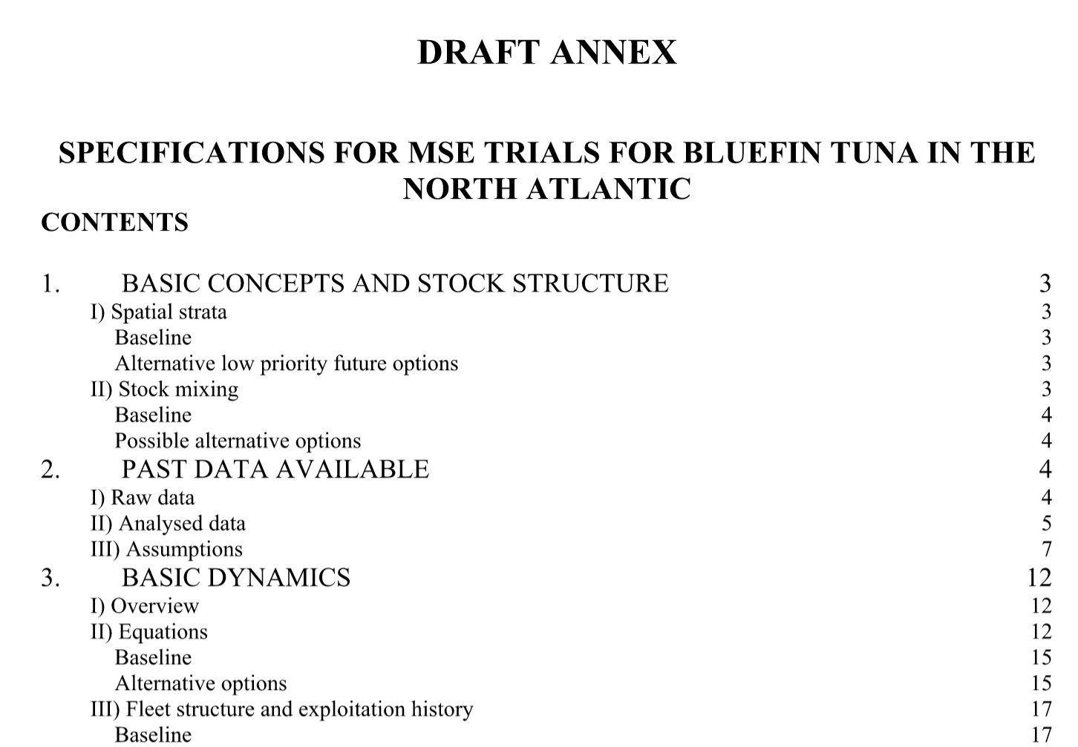

The latest version of the MSE [Trial Specifications document](https://drive.google.com/open?id=1jwOmxgh8DQYeNaQ2eRalPrVF4luV97i2):

## Appendix 2: Meta Database

The [meta-data base](https://drive.google.com/open?id=140HrddEWU_MFHhxizVtaO_uRs48tzPrEgbDMwudl_1M) has been updated (v2.0) to reflect the data that are currently available and those that were used in the fitting of the 36 reference and 4 robustness operating models.

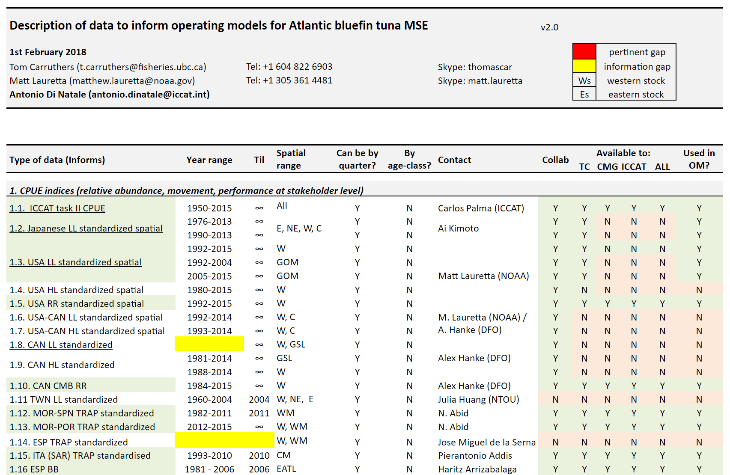

## Appendix 3. SCRS papers.

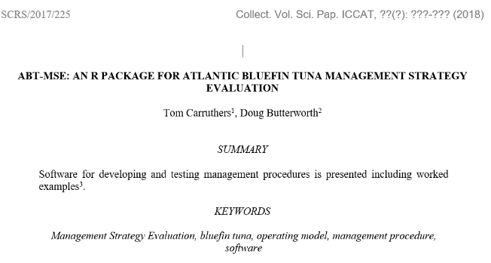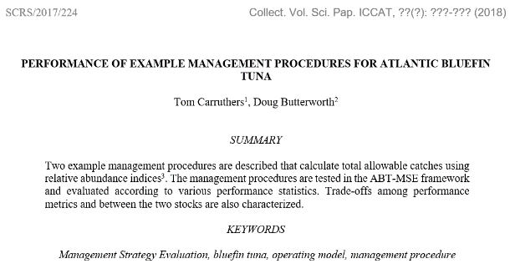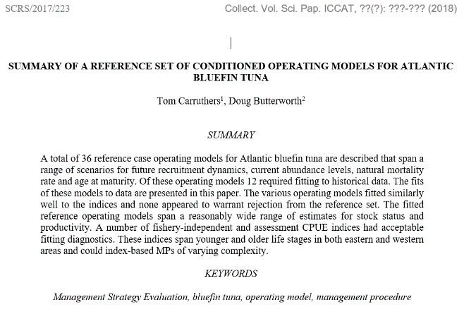

Three SCRS papers were submitted to Redbooks detailing the fits of the reference operating models ([SCRS/2017/223](https://drive.google.com/open?id=1oJmXDD6tRKbEI4DwZnsLbFIAcq1EfiPt)), an example design and testing of a simple management procedure ([SCRS/2017/224](https://drive.google.com/open?id=1gauaI74rowuzY3pAE-qFFlWQuY9wElPI)) and an overview and introduction to the R ABT-MSE package ([SCRS/2017/225](https://drive.google.com/open?id=1IBcZhxNJXwSKkmEoAFoGrj7BhzilNt81))

## Appendix 4: Complete R package for MP testing

## 

All operating models and existing MPs were compiled into a single [R package](https://drive.google.com/open?id=1eJQ_DcZcceYBBJAVNzqkLFxf4VProdZo) complete with live supporting documentation for every object and function.

## Appendix 5: Standardized operating model reporting

In order to rapidly evaluate the fit of operating models to data a [standardized operating model report](https://drive.google.com/open?id=1ppVm2mTsWjZsqtrl-RFQILsmO_OPNpJ0) was developed and refined (an automatic, one-click product) following feedback from the Core Modelling Group.

To compare multiple operating models simultaneously, a [summary report](https://drive.google.com/open?id=1HCzvlkzVStkHZL-As7AOQgYHuQl3-2-C) was also developed.

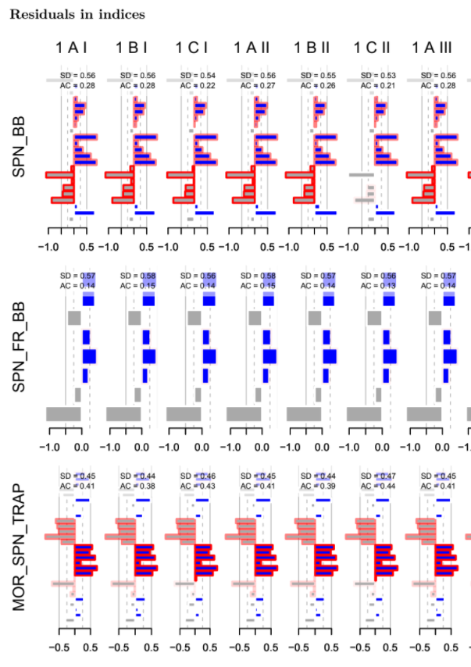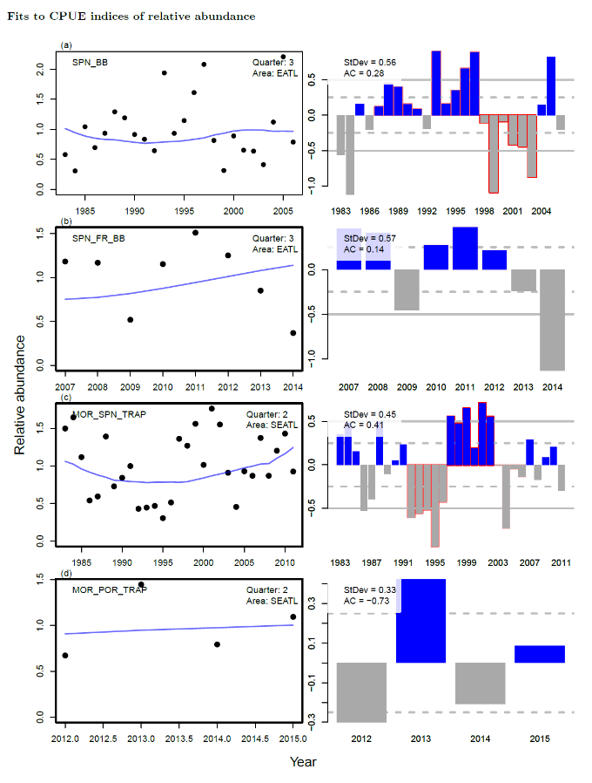

## Appendix 6: Draft peer-review paper on a Multi-stock, Multi-fleet, Multi-area MP

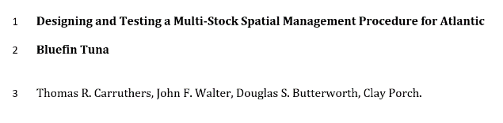

A prospective MP for Atlantic bluefin may have to react to multiple indices with varying lags-to-vulnerable biomass located in spatially distinct areas.

A methodology has been identified (and described in a [draft paper](https://drive.google.com/open?id=1gTsFebF_6jOSfQpsQSvWViVPy0tptHsc)) that could synthesize these data into a single MP providing recommendations simultaneously for both East and West areas.

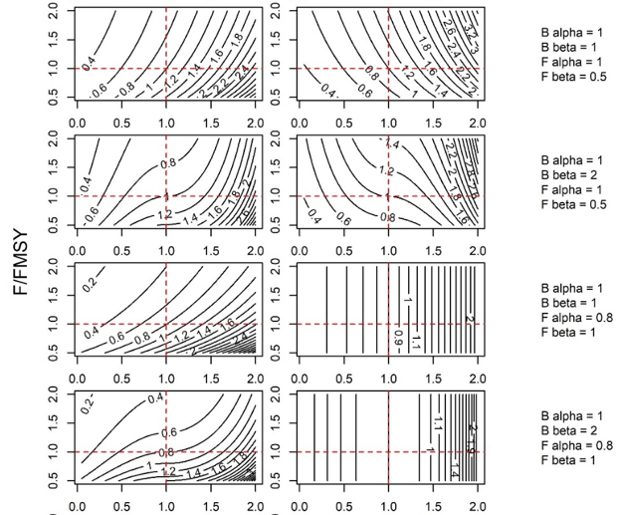

## Appendix 7: Updated M3 user guide

The various requirements of the reference and robustness operating models required modifications to the ADMB M3 model, in particular input file format to accommodate new priors for changes in spawning biomass, relative spawning stock size among East/West areas and stock mixing rates.

The [M3 users guide](https://drive.google.com/open?id=1GwBgtHzPsk4uZVO5wPri8jiPVc-YgPlF) (v1.7) was updated to reflect these changes.

## Appendix 8: R package user guide

The user guide explains the design of the ABT MSE and provides worked examples of the R package functions. The user guide demonstrates the 7 steps of MSE covering custom management procedures, performance metrics and operating models. The user guide is accessible from [here](https://drive.google.com/open?id=0B0HYOP0BN5RPV1BXOGk0cEwyTGM).

## Appendix 9: Software design documents

Following updates to the R package the [Software Design Document for the R Package](https://drive.google.com/open?id=1OcadeChBHx3SFouqayIBg6NuzgMSkwSR) was updated to reflect new priorities and considerations for future phases with an emphasis on MP development.

1. [bluemattersci@gmail.com](mailto:bluemattersci@gmail.com) 2150 Bridgman Ave, North Vancouver, Canada. +1 604 822-6903